AI ASSISTED CODING
ASSINGMENT-3
NAME:K.POORNACHANDER
HALL.TICKET NUMBER:2403A52382
BATCH: AI 14
Task Description#1
- Ask AI to write a function to calculate compound interest, starting with only the function name. Then add a docstring, then input-output example
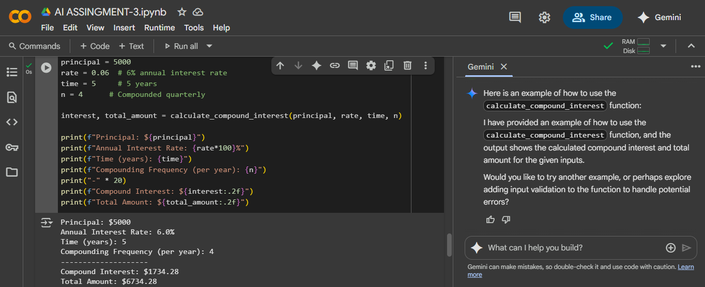

EXPLANITION:
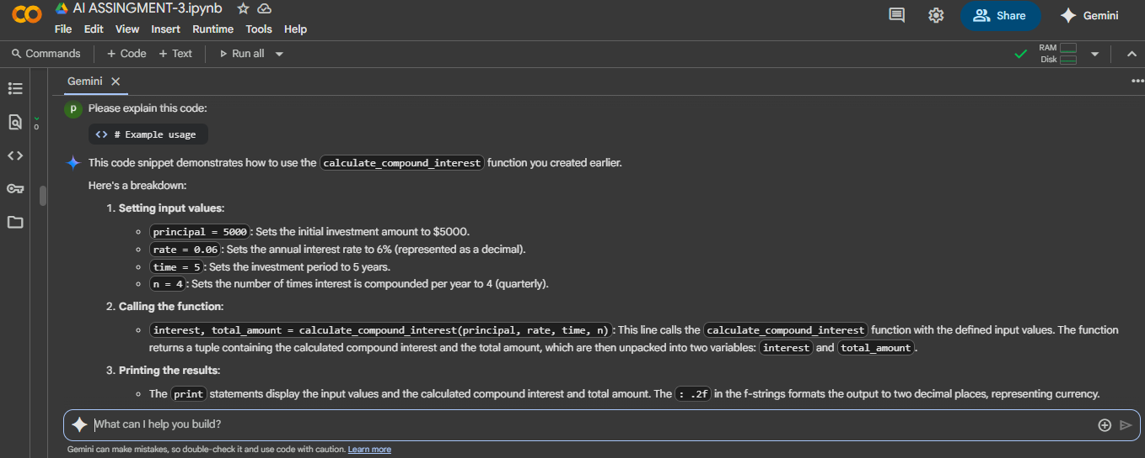

Task Description#2
Do math stuff, then refine it to: # Write a function to calculate average, median, and mode of a list of numbers
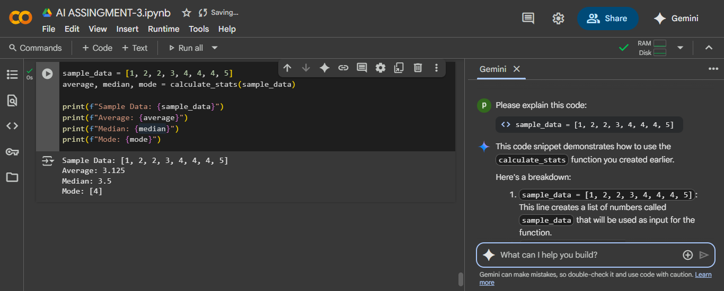
EXPLANITION:
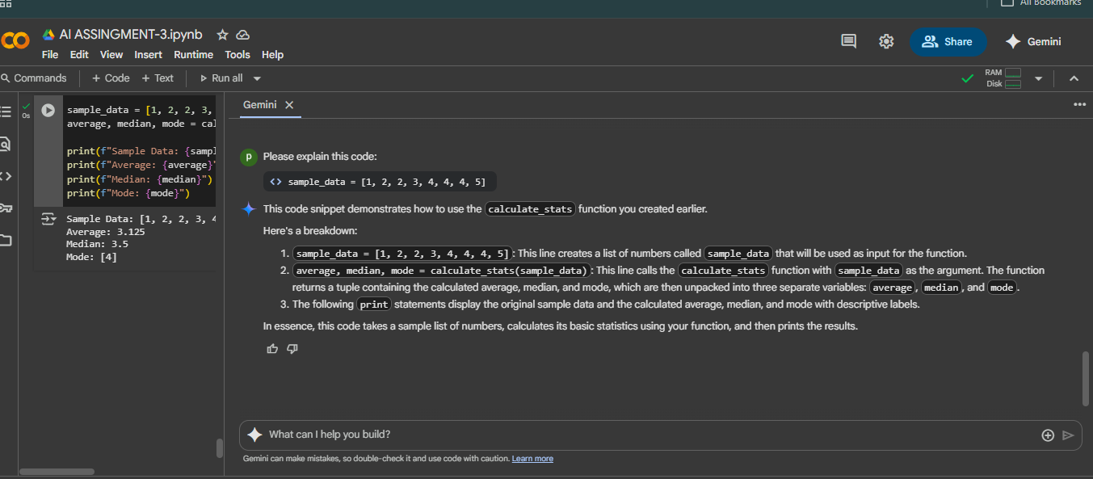
Task Description#3
Provide multiple examples of input-output to the AI for convert_to_binary(num) function. Observe how AI uses few-shot prompting to generalize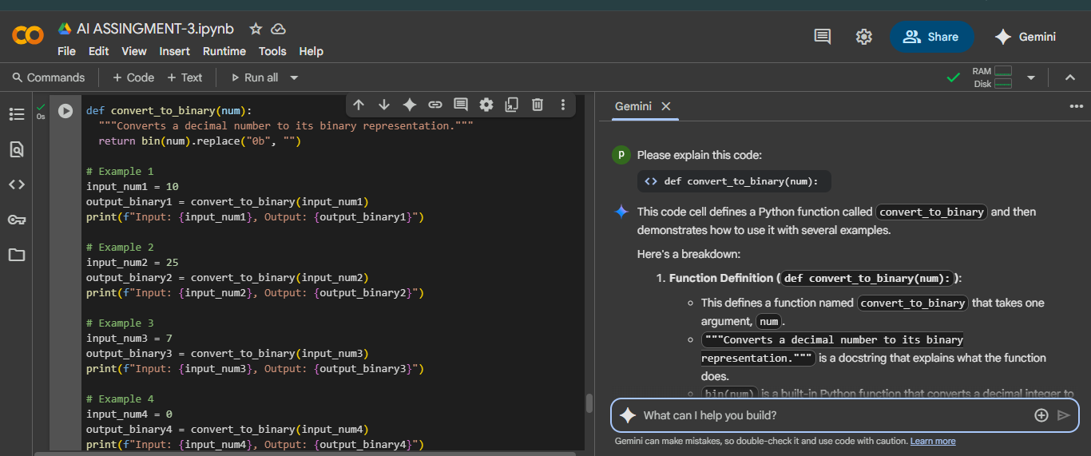
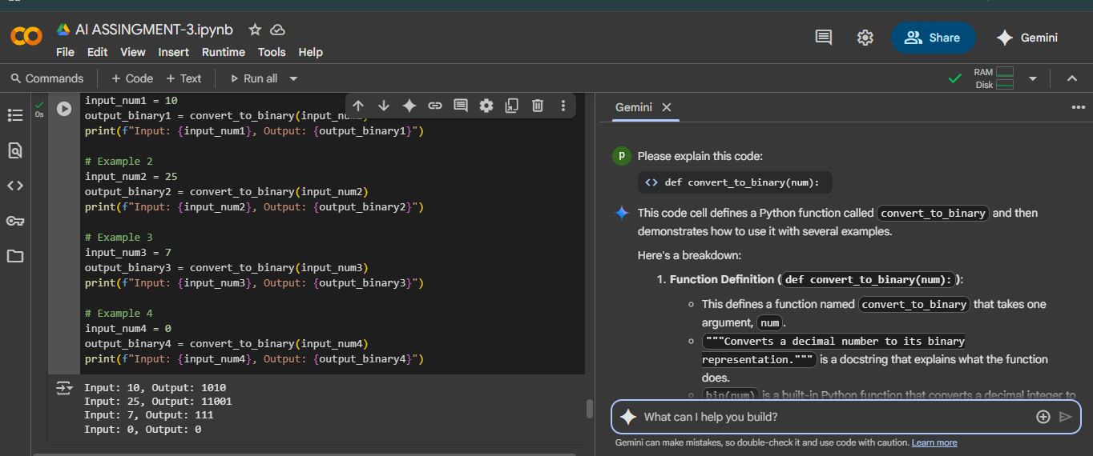

EXPLANITION:
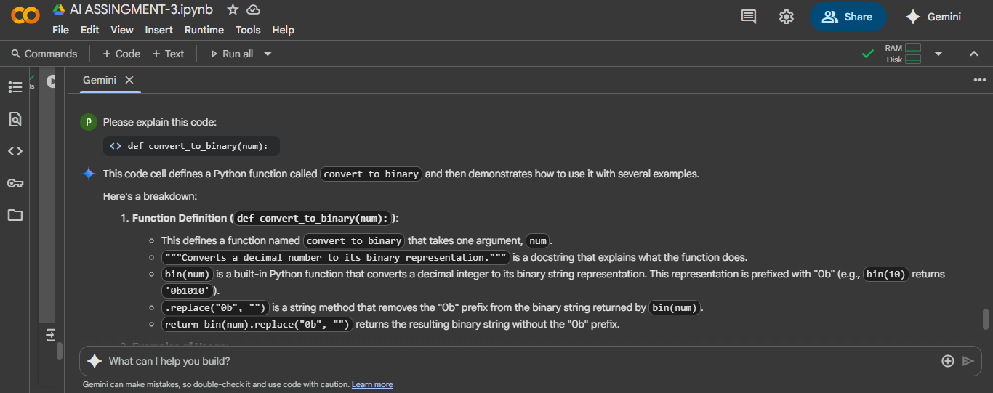
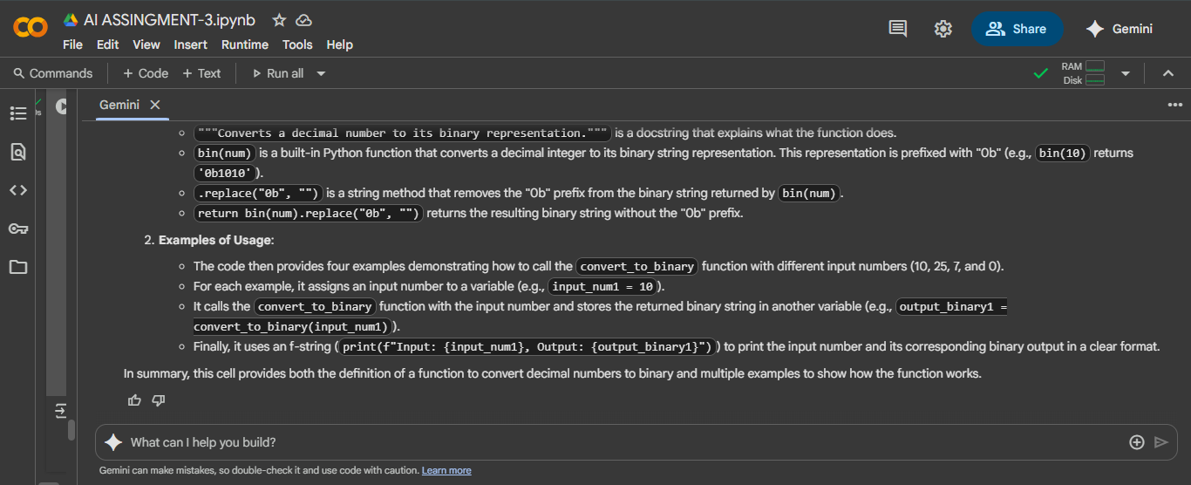

Task Description#4
- Create an user interface for an hotel to generate bill based on customer requirements
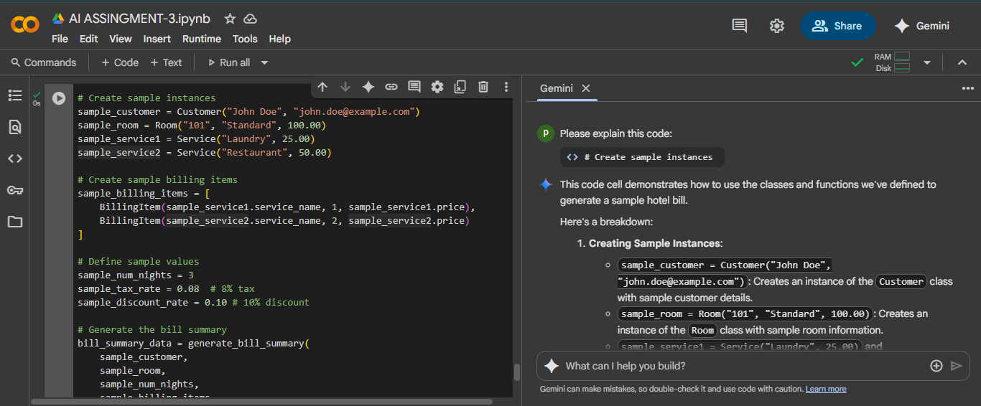
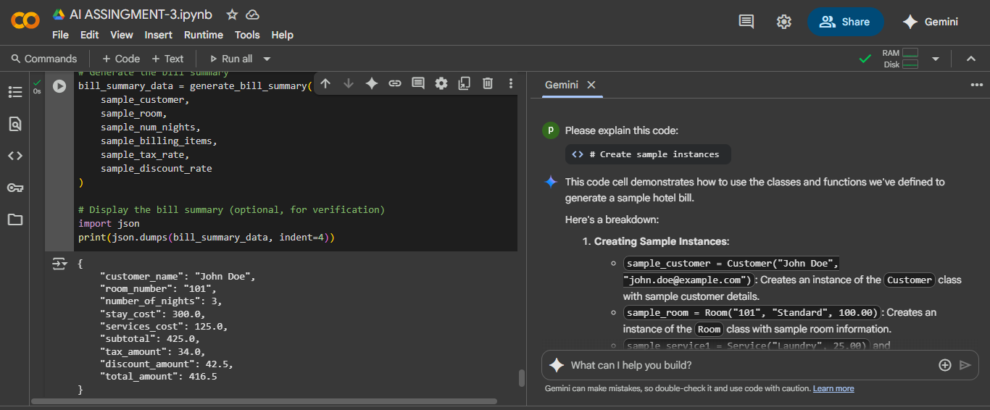
EXPLANITION:
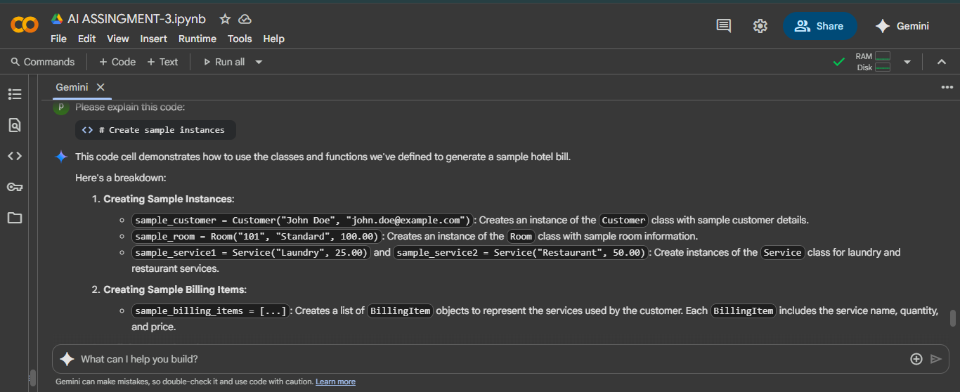
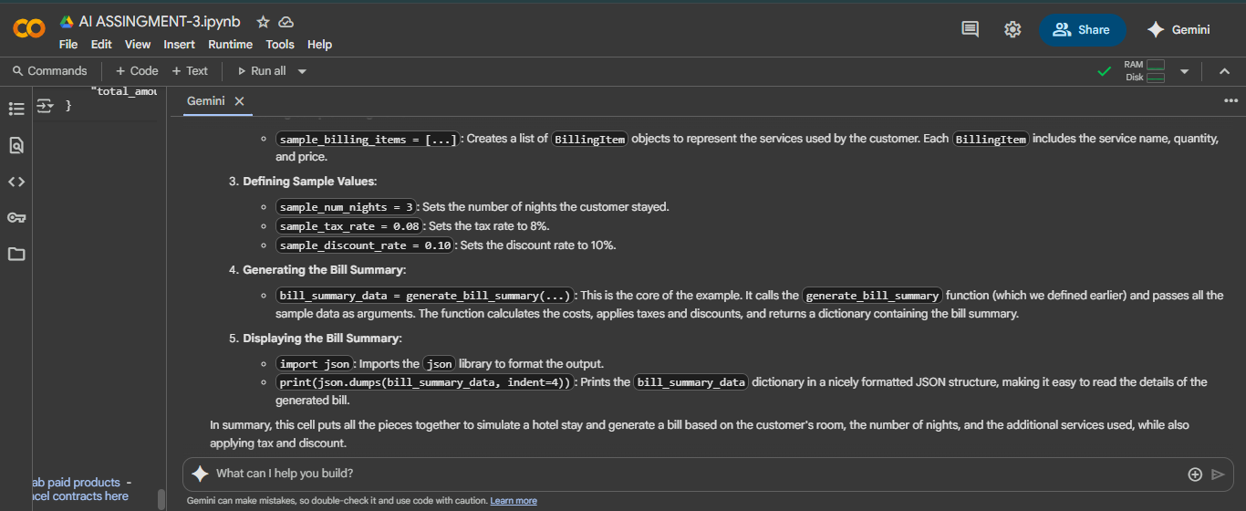
Task Description#5
- Analyzing Prompt Specificity: Improving Temperature Conversion Function with Clear Instructions
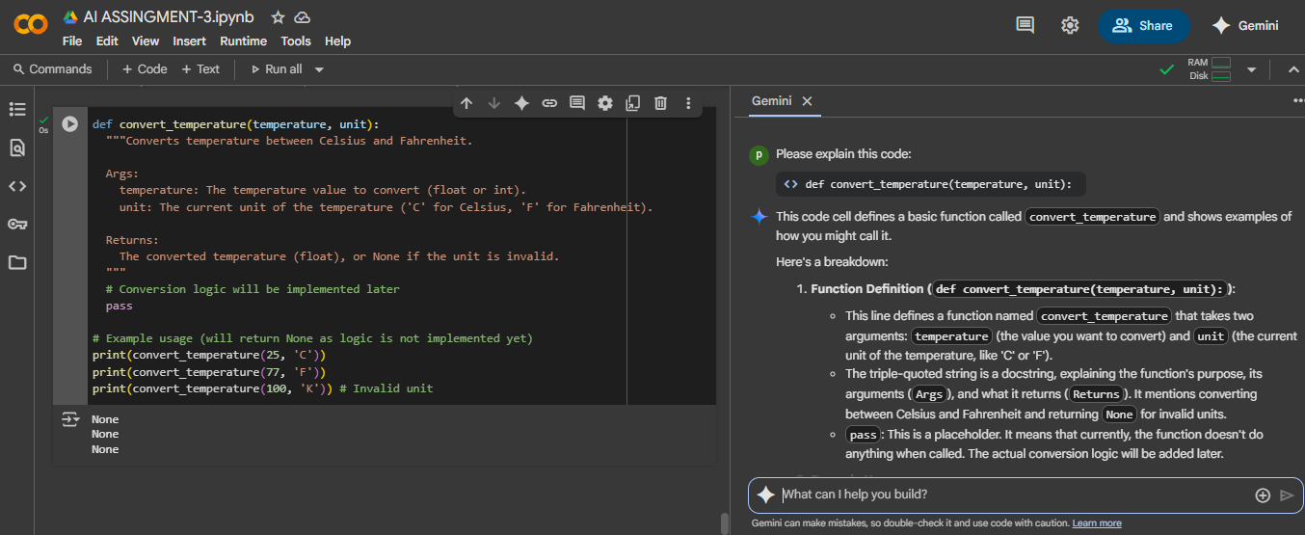

EXPLAINITION:
